**Exercise 5.**

Statistical Analysis.

Table of Contents

List of Figures 1

Abstract 3

Part 1: Non-inverting Amplifier Analysis 4

Part 2: MC Analysis of the Comparator with Feedback 14

Part 3: Analysis of Band-Pass filter 21

Part 4: Homework 26

# List of Figures

Figure 1 Diagram of the Tested Amplifier Circuit. 4

Figure 2 Plot Characteristic. 4

Figure 3 .meas calculations. 5

Figure 4 Scheme of the Tested Amplifier Circuit for MC analysis. 5

Figure 5 Plot Characteristic. 5

Table 6 Gain Measurements. 8

Figure 7 stepped measurements of gain. 8

Figure 8 Graph of the histogram. 8

Figure 9 Graph of the histogram Close Up. 9

Figure 10 Gaussian Distribution in Tolerance 9

Figure 11 Diagram of the Tested Amplifier Circuit for WC analysis. 10

Figure 12 Plot Characteristic. 10

Table 13 Gain Measurement 10

Figure 14 New Diagram of the Tested Amplifier Circuit for WC analysis. 11

Figure 15 New Plot Characteristic. 11

Figure 16 New Gain Measurements 11

Figure 17 Diagram of The Tested Amplifier Circuit for WC Analysis Taking into Account Temperature Changes. 12

Figure 18 Plot Characteristic. 12

Table 19 Gain Measurements 13

Figure 20 Diagram of the Tested Comparator System. 14

Figure 21 Plot Characteristic. 14

Figure 22 Hysterisis. 15

Figure 23 Diagram of the tested comparator system for MC analysis. 15

Figure 24 Plot Characteristic. 16

Figure 25 Modified Circuit. 16

Figure 26 HYS STEP Results 19

Figure 27 Histogram 19

Figure 28 Diagram of The Tested Comparator System for WC Analysis. 20

Figure 29 Plot Characteristic. 20

Figure 30 Diagram of the tested filter system. 21

Figure 31 Plot Characteristic. 21

Figure 32 Quality Factor From Previous Exercise 22

Figure 33 Diagram of the tested filter system for MC analysis. 22

Figure 34 Plot Characteristic. 23

Figure 35 x=mag(vout) 24

Figure 36 Scheme of the tested filter system for WC analysis. 24

Figure 37 Plot Characteristic. 25

Figure 38 x=mag(vout) 25

Figure 39 Band Pass Filter Circuit. 26

Figure 40 Plot Characteristic. 26

Figure 41 Quality Factor. 27

Figure 42 Diagram of a transistor amplifier 27

Figure 43 Plot Charactersistic 28

Figure 44 MC Analysis. 28

Figure 45 Plot Characteristic. 29

Figure 46 WC Analysis. 29

Figure 47 Plot Characteristic. 29

Figure 48 WC with TEMP. 30

Figure 49 Plot Characteristic. 30

# Abstract

The aims of this laboratory exercise were learning how to define statistical analyzes Monte Carlo (MC) and Worst Case (WC) in Ltspice and interpret simulated data into histogram.

# Part 1: Non-inverting Amplifier Analysis

For begin our exercises we will conduct an analysis of the amplifier circuit for nominal values. Therefore to start we must firstly create an amplifier circuit. In the figure below please see such circuit scheme, find the operational amplifier used being OP37. We have a sinusoidal input. Using the parameters we can measure the precise or ideal voltage gain from this circuit. Realistically these values will be a little different as each component as well as the conditions will affect the circuit.

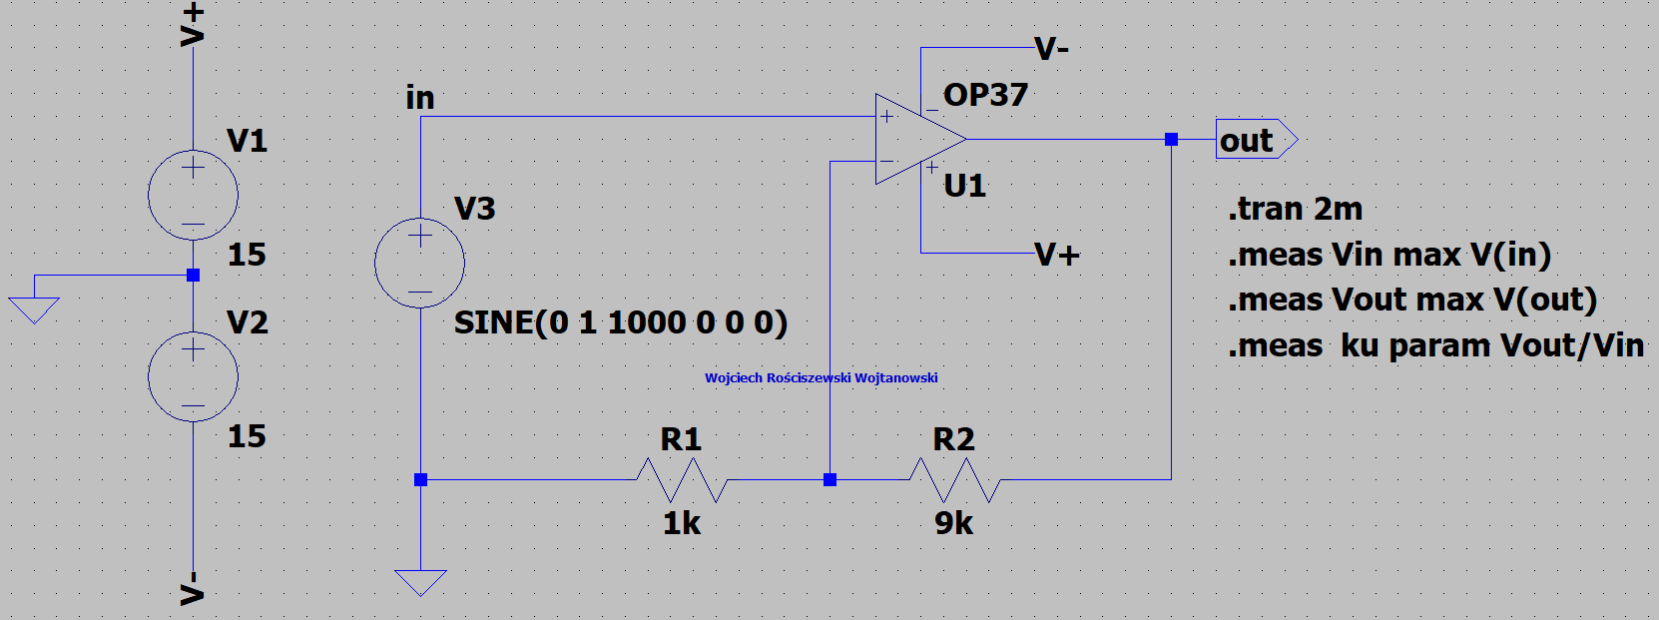

Figure 1 Diagram of the Tested Amplifier Circuit.

We performed transient analysis and measured all the minimal and maximal values from which we can calculate the gain coefficient ku. Our general voltage source is sinusoidal input, we determine the amplitude of 1v. This is for ideal situation, when we have 1k and 9k, so not taking into consideration other factors influencing this. The gain of this circuit should be 10V. In the below please see the plot characteristic, we see the blue line is our input signal from voltage source V3. The green line is our output characteristic. We clearly see our signal is amplified, but by how much?

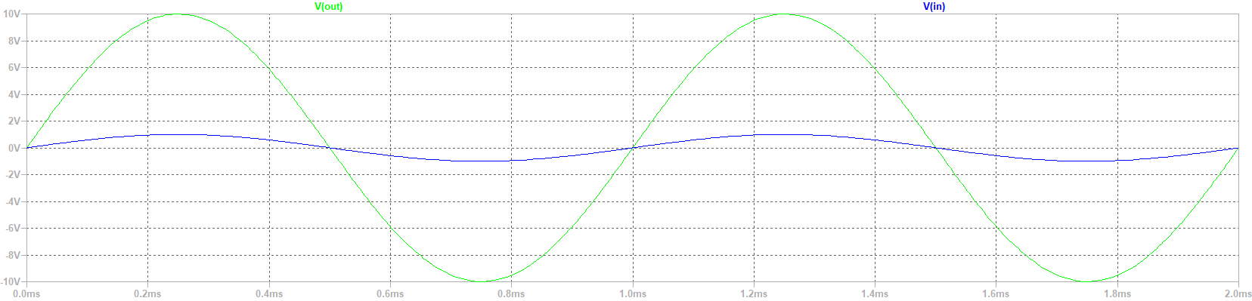

Figure 2 Plot Characteristic.

In the below please find a figure presenting the previously mentioned gain calculation. Please see we calculated this from comparing the Vin and Vout voltage values, all of this has been only done by the spice directives .meas so our calculations should be considered very precise as they come directly from the simulation. We see the gain value is almost close to 10V of original signal, which seems quite accurate.



Figure 3 .meas calculations.

For the next part of the exercise we will perform the Monte Carlo (MC) analysis of the amplifier circuit previously created. In the below please see the completed circuit. Please see that the tolerance of the resistive components has been set to 10%. We did this by setting a variable to 10% and then expanding it onto each resistive element requiring such tolerance assumption. Please see tol variable under resistors and tol parameter setting.

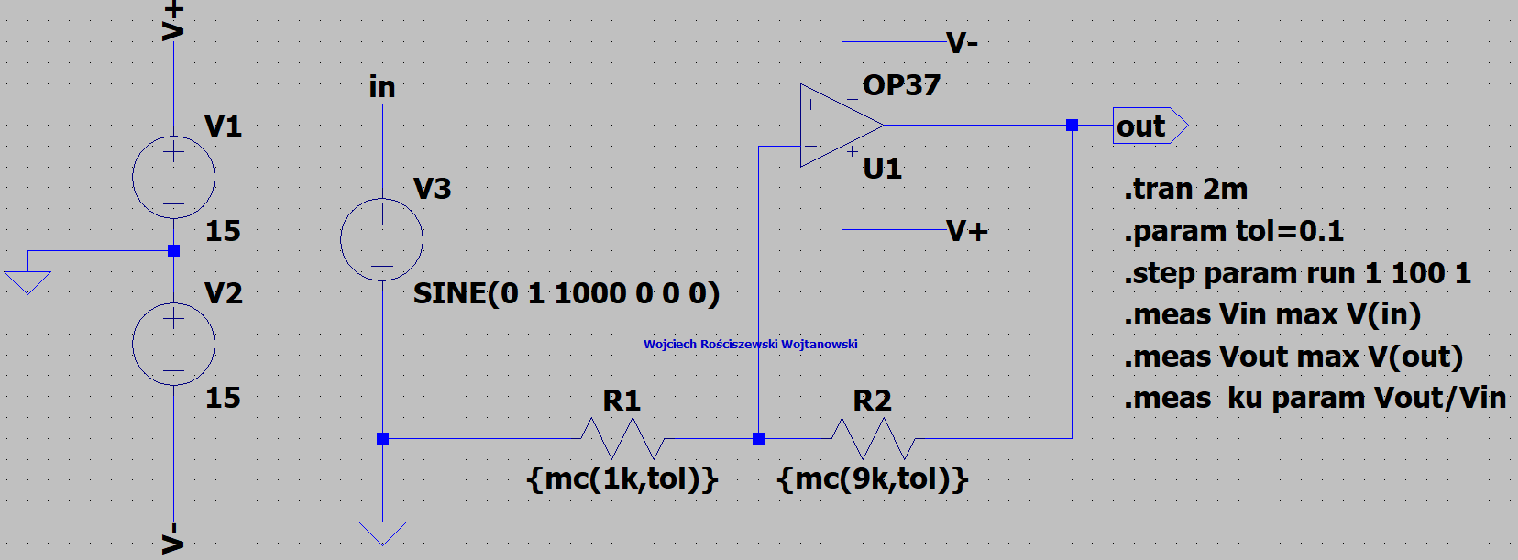

Figure 4 Scheme of the Tested Amplifier Circuit for MC analysis.

In the below please see the output. Circuit is working correctly. There are 100 steps analyzed in this simulation.

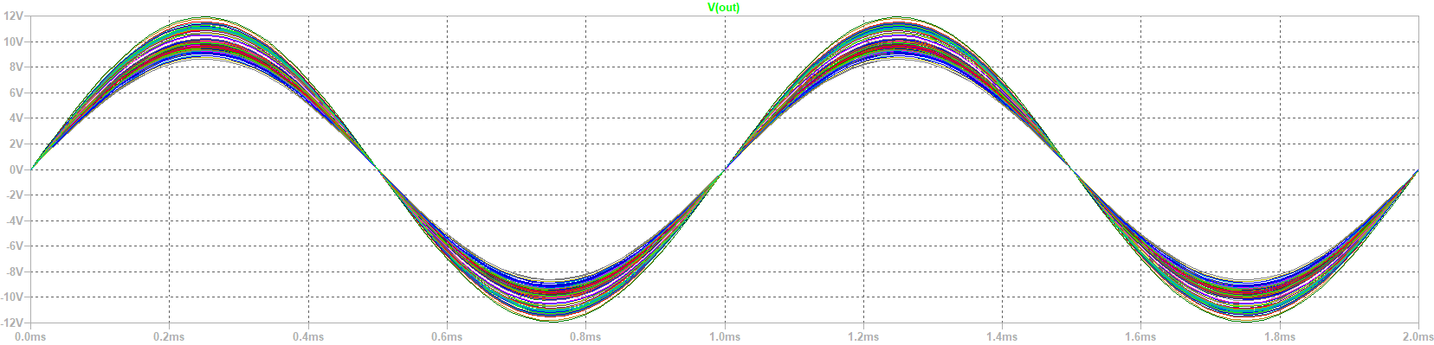

Figure 5 Plot Characteristic.

For the next part of the exercise we must determine the ranges of which the gain changes towards. Please see the measured corresponding values for this. Measurement of ku gain values:

|  |  |
| --- | --- |
| **STEP** | **VOUT/VIN** |
| 1 | 11.1239 |
| 2 | 11.1797 |
| 3 | 9.81352 |
| 4 | 11.0121 |
| 5 | 9.8707 |
| 6 | 11.3182 |
| 7 | 9.65939 |
| 8 | 9.45819 |
| 9 | 10.5348 |
| 10 | 10.0356 |
| 11 | 9.10949 |
| 12 | 9.77667 |
| 13 | 10.7361 |
| 14 | 10.0703 |
| 15 | 10.0091 |
| 16 | 10.9578 |
| 17 | 9.82024 |
| 18 | 11.0871 |
| 19 | 10.0324 |
| 20 | 9.6089 |
| 21 | 9.74966 |
| 22 | 9.94979 |
| 23 | 9.29053 |
| 24 | 9.58835 |
| 25 | 8.90424 |
| 26 | 10.1087 |
| 27 | 10.0043 |
| 28 | 9.61392 |
| 29 | 10.0583 |
| 30 | 8.62372 |
| 31 | 9.47682 |
| 32 | 8.9201 |
| 33 | 11.816 |
| 34 | 9.99396 |
| 35 | 10.1823 |
| 36 | 9.81224 |
| 37 | 9.49488 |
| 38 | 9.52718 |
| 39 | 10.8912 |
| 40 | 8.90791 |
| 41 | 9.62224 |
| 42 | 9.78291 |
| 43 | 9.62513 |
| 44 | 10.1419 |
| 45 | 10.6898 |
| 46 | 10.8478 |
| 47 | 9.3038 |
| 48 | 10.9409 |
| 49 | 9.22731 |
| 50 | 9.66218 |
| 51 | 11.5528 |
| 52 | 11.4801 |
| 53 | 9.32392 |
| 54 | 9.34897 |
| 55 | 9.53301 |
| 56 | 11.3999 |
| 57 | 9.59436 |
| 58 | 9.97377 |
| 59 | 9.42089 |
| 60 | 10.673 |
| 61 | 9.43812 |
| 62 | 10.5441 |
| 63 | 10.1274 |
| 64 | 9.57458 |
| 65 | 10.4761 |
| 66 | 8.65068 |
| 67 | 10.2614 |
| 68 | 9.41221 |
| 69 | 9.95341 |
| 70 | 9.63681 |
| 71 | 9.82447 |
| 72 | 9.10734 |
| 73 | 9.66509 |
| 74 | 8.87496 |
| 75 | 9.70429 |
| 76 | 11.083 |
| 77 | 9.25495 |
| 78 | 10.7001 |
| 79 | 11.9221 |
| 80 | 9.07332 |
| 81 | 9.39636 |
| 82 | 9.63529 |
| 83 | 9.19733 |
| 84 | 8.7886 |
| 85 | 11.2358 |
| 86 | 11.1718 |
| 87 | 10.0941 |
| 88 | 11.1494 |
| 89 | 9.78598 |
| 90 | 10.2589 |
| 91 | 9.79462 |
| 92 | 10.1183 |
| 93 | 10.0783 |
| 94 | 9.81814 |
| 95 | 9.03971 |
| 96 | 10.6643 |
| 97 | 9.88638 |
| 98 | 9.16169 |
| 99 | 9.57161 |
| 100 | 9.29661 |

Table Gain Measurements.

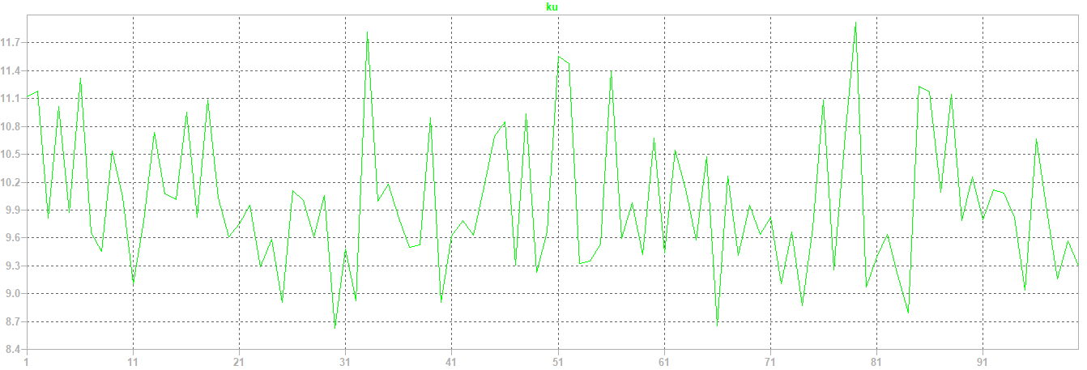

Figure 7 stepped measurements of gain.

Average gain value of our output port is 9.977006 [V].

Below please find the distribution of our gain of our produced amplifier.

Figure 8 Graph of the histogram.

Below please find a closed up:

Figure 9 Graph of the histogram Close Up.

So, when performing the Monte Carlo simulation we change value of resistor, so nominal value for example can be 1kΩ. If we simulate with tolerance included, such as 10%. Our value of our resistor can change from values 0.9kΩ to 1.1kΩ. This is called gaussian distribution, in the below please find a figure presenting the described. We see the values such as 1kΩ appearing more often, whilst values such as 0.9kΩ/1.1kΩ occurs less often. In LTspice we cannot really control this, in other program we can control these by changing the type of the distribution, as there are more available. Generally, we use gaussian as it is somewhat a norm or default option even in other programs.

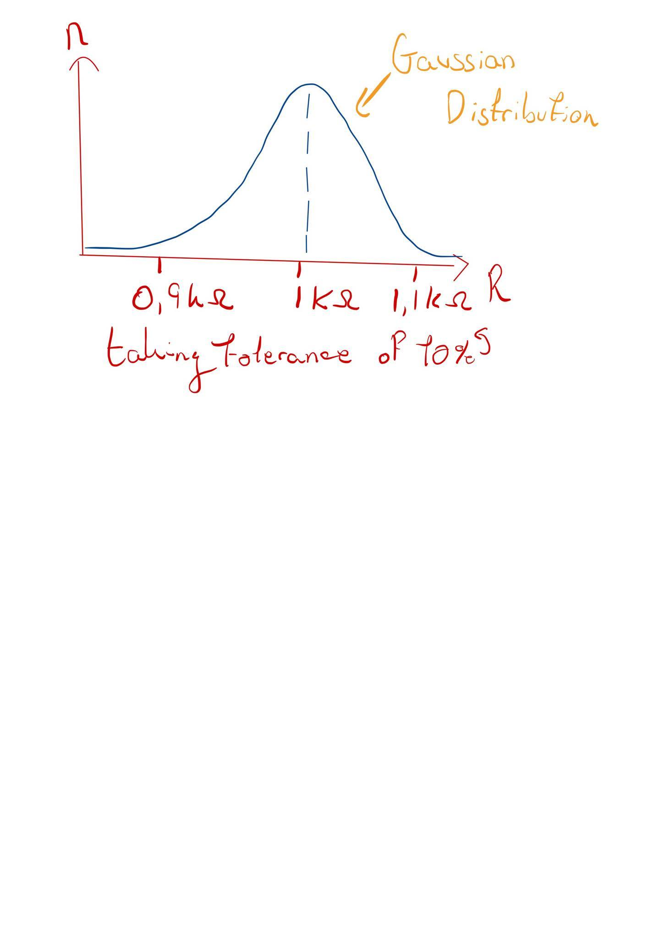

Figure 10 Gaussian Distribution in Tolerance

The next part of the exercise is to modify the previous circuit and perform the worst case (WC) analysis of the amplifier. Please find the figure below presenting the circuit diagram.

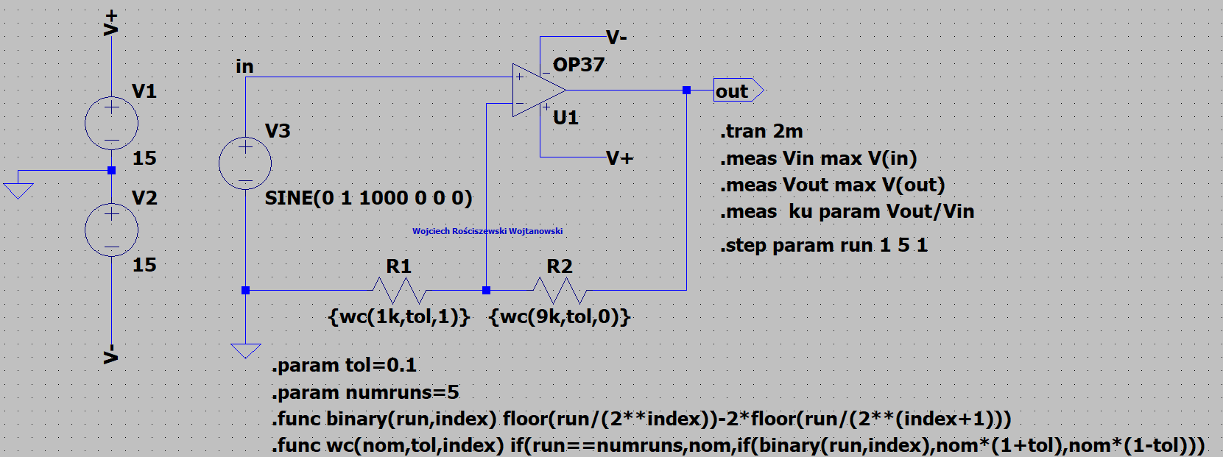

Figure 11 Diagram of the Tested Amplifier Circuit for WC analysis.

In the below please see the circuit output. We see our five steps, where only thee are visible.

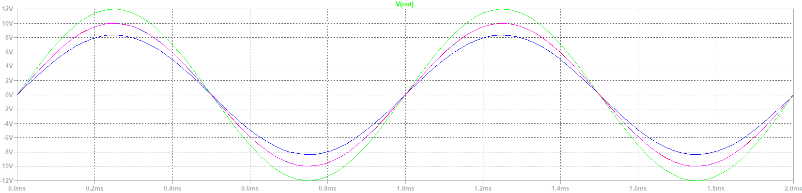

Figure 12 Plot Characteristic.

We must determine the gain characteristic of this therefore please see the output of the .meas directive. We see that we have a gain by comparing the input and output voltages.

|  |  |
| --- | --- |
| **STEP** | **VOUT/VIN** |
| 1 | 11.9996 |
| 2 | 8.36328 |
| 3 | 9.99957 |
| 4 | 9.99959 |
| 5 | 9.99959 |

Table Gain Measurement

Average gain in our output is: 10.072326 [V].

Tolerance was 10%, tol=0.1. Gain is ku=8, till ku12. We run simulation for 100 steps.

For the next part we will change the tolerance of the resistors to 1%. In the below please see modified circuit where only the tolerance parameter was modified.

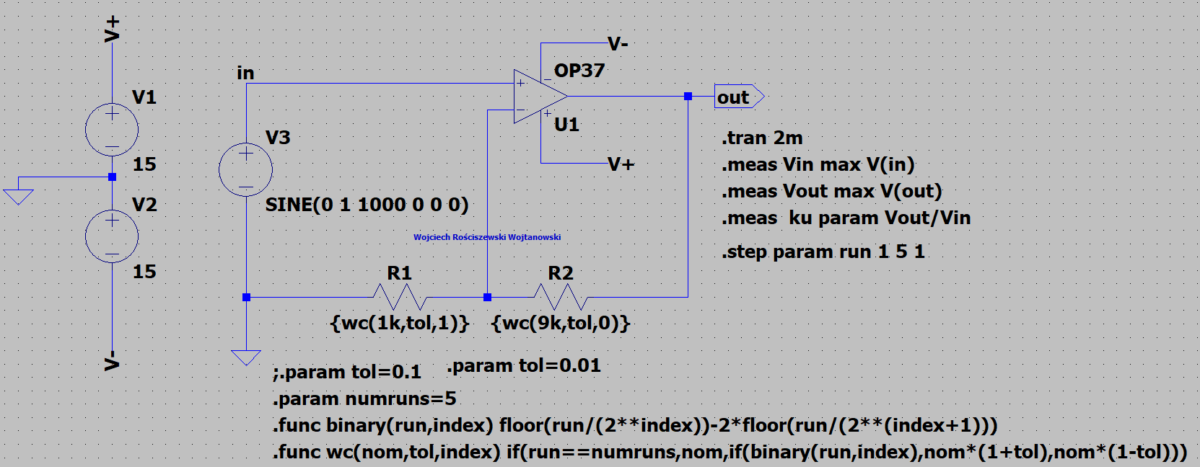

Figure 14 New Diagram of the Tested Amplifier Circuit for WC analysis.

In the below please see the output of the circuit, we see that the tolerance of the resistor affects the circuit state output greatly.

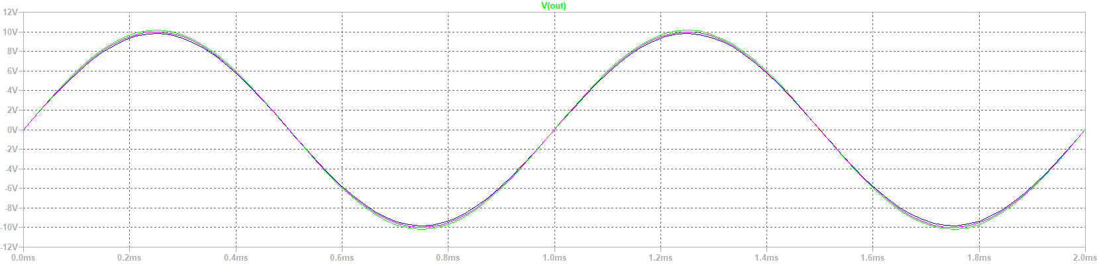

Figure 15 New Plot Characteristic.

Since out output waveform has changed, we know the gain has also changed therefore, please see the below table as well as calculated average.

|  |  |
| --- | --- |
| **STEP** | **VOUT/VIN** |
| 1 | 10.1814 |
| 2 | 9.82138 |
| 3 | 9.99959 |
| 4 | 9.99959 |
| 5 | 9.99959 |

Figure New Gain Measurements

Average gain in our output is: 10.00031 [V]. Previously we had, 10.072326. Our system is more precise I assume, since we are getting closed to 10V!

For the next part of the exercise we will determine the worst-case analysis of our amplifier circuit but this time we will take into account the temperature limits at which the tested system (and elements) can operate in between the temperatures of -55°C and 125°C. In the below please see the modified circuit and directives that suit this amplifier circuit characteristics.

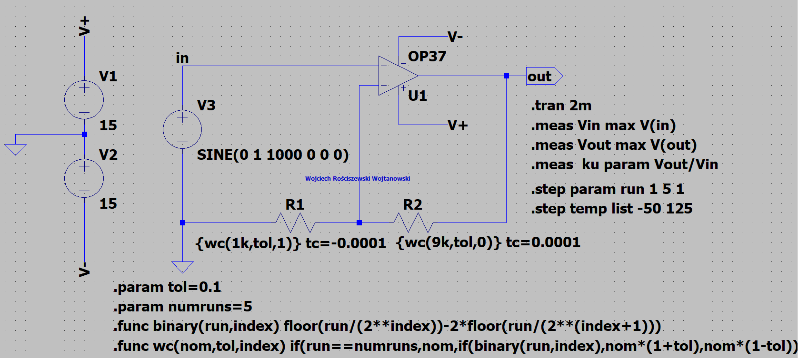

Figure 17 Diagram of The Tested Amplifier Circuit for WC Analysis Taking into Account Temperature Changes.

In the below please see the output of our circuit

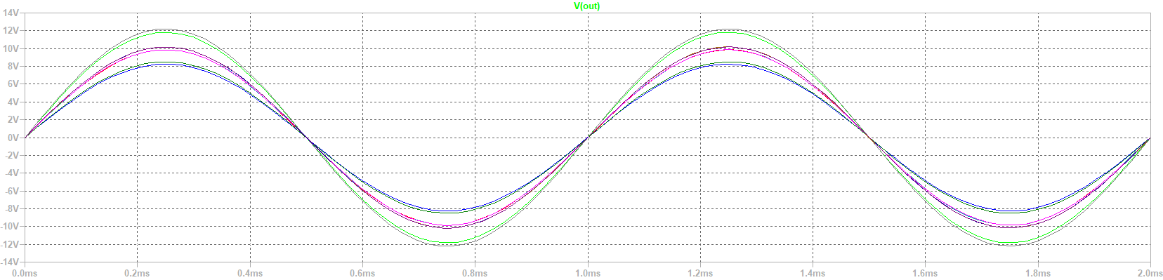

Figure 18 Plot Characteristic.

In the below please see the gain measurements of our output values from circuit along with the average gain value.

|  |  |
| --- | --- |
| **STEP** | **VOUT/VIN** |
| 1 | 11.8314 |
| 2 | 8.25075 |
| 3 | 9.86204 |
| 4 | 9.86206 |
| 5 | 9.86206 |
| 6 | 12.2173 |
| 7 | 8.50904 |
| 8 | 10.1777 |
| 9 | 10.1777 |
| 10 | 10.1777 |

Table Gain Measurements

Average gain in our output is: 10.092775 [V]. From all of the information we can compare from previous circuits that the temperature has minimalistic effects on the results of given circuits. In the case of very sensitive electrical circuits such as radio heads the temperature can greatly affect these elements, as a radio receiver circuit will be out of tune and will change it’s tuning, for example in a famous polish radio amplifier Radmor 51XX. In this receiver I personally seen the radio escape from its true parameters because of a diode heating up. Temperature of a circuit is extremely important as it affects the scheme parameters, again implies for only really sensitive circuits.

# Part 2: MC Analysis of the Comparator with Feedback

For this part of the exercise we will perform analysis on the comparator system for only nominal values. Therefore, we must create a comparator system with a feedback. In the below figure please see such circuit scheme presented.  
Yes, I have created my own component with the information I have gathered from the internet that’s why the LT1021-5 module has a different symbol. It is exactly the same as the original LT1021-5 component. This was created as I couldn’t find the module in LTspice component search, so I decided to improvise. I have later found the module in the References folder. This clearly shows that the previous labs have been sufficient enough for me to improvise during such situations.

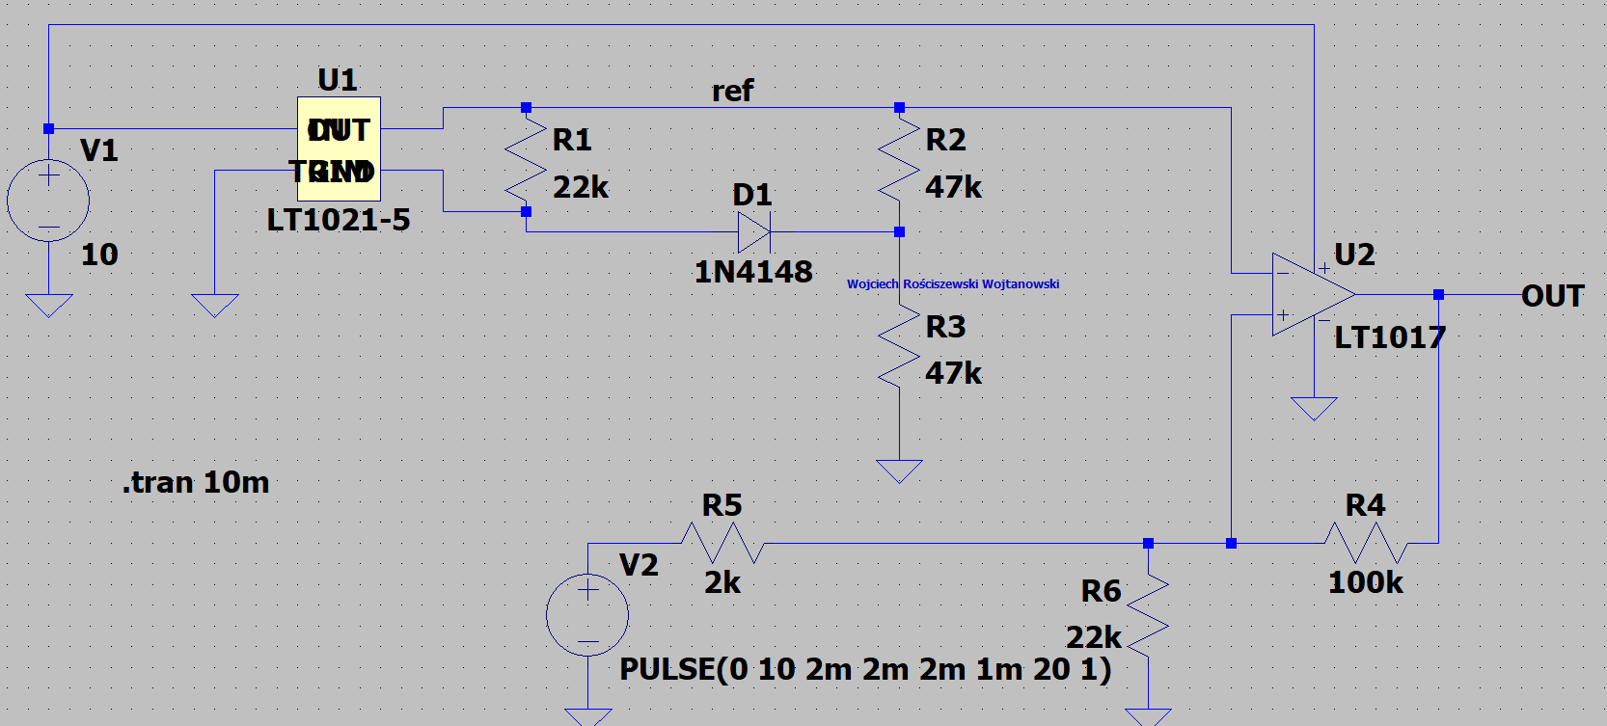

Figure 20 Diagram of the Tested Comparator System.

In the below please see the output of our circuit.

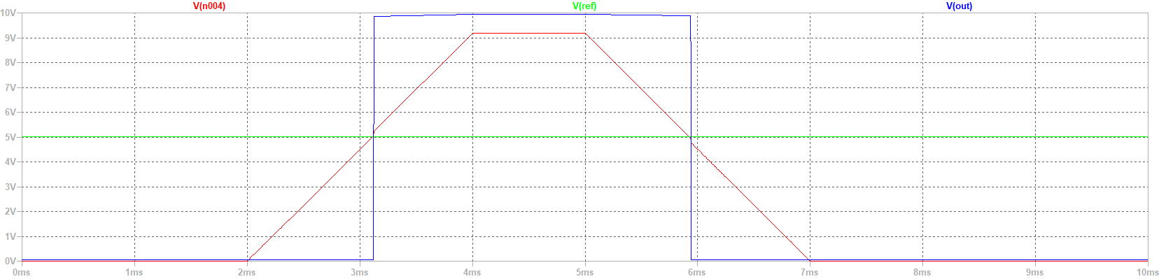

Figure 21 Plot Characteristic.

Please see the green and trapezoidal shape being our two inputs, with one being our steady voltage (V1) whilst the other being our pulse (V2). The square wave in blue is our output value characteristic. We must now calculate the hysteresis voltage. Hysteresis else known as the Schmitt trigger circuit. It means that once the output is triggered into the saturation phase there will be some change to the input signal before our output will be switched back at the original saturation phase point. We must calculate this difference here. We are working with a non-inverting operation amplifier. In more detail the LT1021-5 V(ref)=5V whilst the output signal of our V2 voltage source is equal to zero and then it rises for the first 2ms (pulse function), the voltage output of comparator depends on V2 and comparator switching voltage, so 0 -10V.

Below is the gain of this circuit: **vin:**

**MAX(v(in))=9.18068 FROM 0 TO 0.01**

**vout: MAX(v(out))=9.94579 FROM 0 TO 0.01**

**ku: vout/vin=1.08334**

From calculating the VUTP (upper voltage trip point) and VLTP (lower voltage trip point). We in fact don’t calculate this but rather find the correct points on the graph. Since we are comparing the difference between the output and input, how the system changes the values! Find circled in blue exactly what is meant. VHYS=VUTP-VLTP = 5.046-4.769 = 0.277.

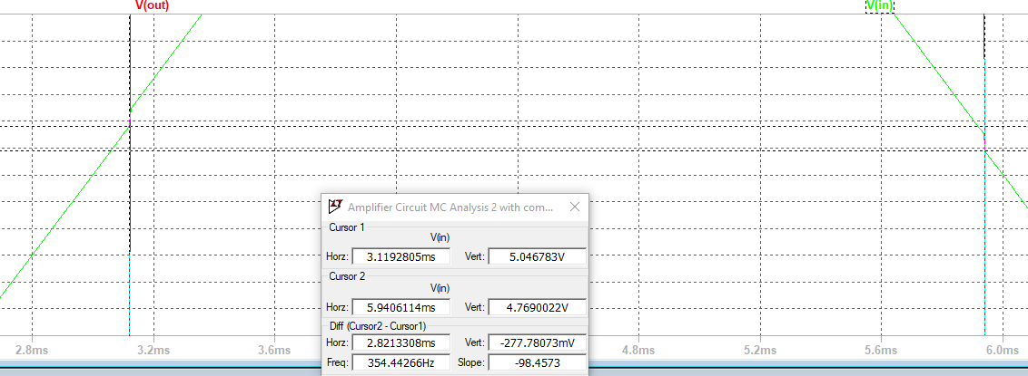

Figure 22 Hysterisis.

The next step of the exercise is to modify the circuit to run a parameter sweep, also change the resistor values to 10% and see how it affects the system. Please see the figure below presenting comparator system for MC analysis.

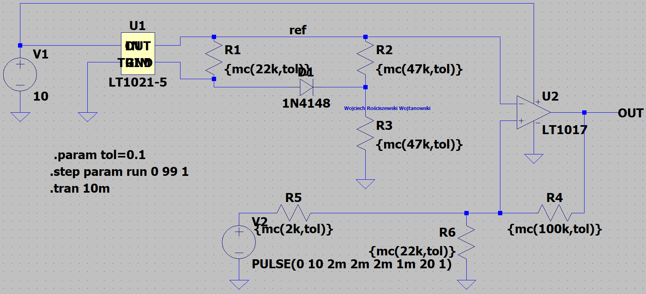

Figure 23 Diagram of the tested comparator system for MC analysis.

In the below please see the output of our circuit

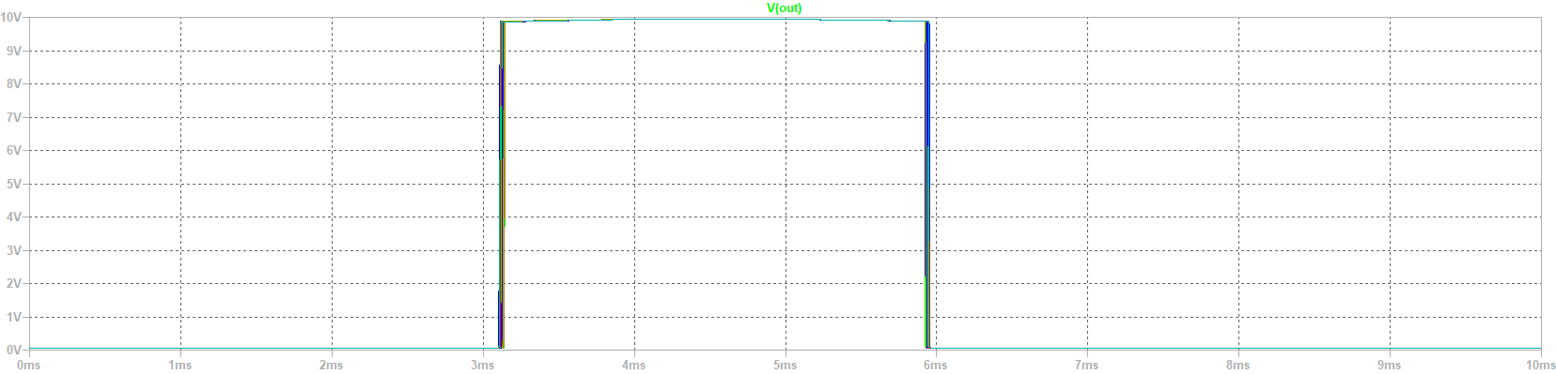

Figure 24 Plot Characteristic.

We must calculate this difference here. From calculating the VUTP (upper voltage trip point) and VLTP (lower voltage trip point). We in fact don’t calculate this but rather find the correct points on the graph. Since we are comparing the difference between the output and input, how the system changes the values this time we have a tolerance change!

So since we are stepping originally throughout this simulation I will create another histogram presenting this. This isn’t asked directly in the manual however I assume that this should be included. Therefore, I have written a simple LTspice directive to calculate this for us, below please find two figures: the table presenting our hysteresis and our histogram. Additionally, I will include the average HYS value.

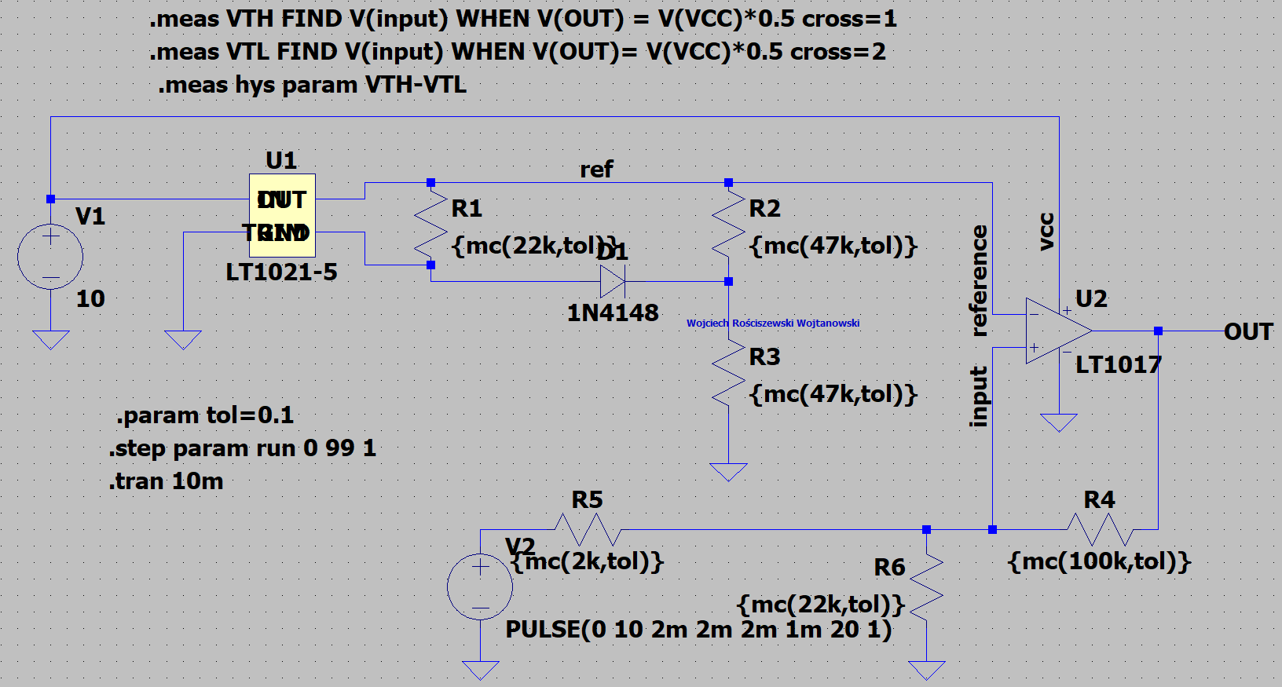

Figure Modified Circuit.

|  |  |
| --- | --- |
| **STEP** | **VTH-VTL** |
| 1 | 0.273588 |
| 2 | 0.265754 |
| 3 | 0.284627 |
| 4 | 0.268473 |
| 5 | 0.282516 |
| 6 | 0.272701 |
| 7 | 0.301115 |
| 8 | 0.290674 |
| 9 | 0.286268 |
| 10 | 0.295619 |
| 11 | 0.282654 |
| 12 | 0.286096 |
| 13 | 0.28254 |
| 14 | 0.293057 |
| 15 | 0.289567 |
| 16 | 0.276301 |
| 17 | 0.271396 |
| 18 | 0.283554 |
| 19 | 0.278287 |
| 20 | 0.271672 |
| 21 | 0.285109 |
| 22 | 0.293704 |
| 23 | 0.313476 |
| 24 | 0.294985 |
| 25 | 0.296272 |
| 26 | 0.285363 |
| 27 | 0.297102 |
| 28 | 0.300539 |
| 29 | 0.261458 |
| 30 | 0.278303 |
| 31 | 0.308715 |
| 32 | 0.285021 |
| 33 | 0.292827 |
| 34 | 0.292751 |
| 35 | 0.273864 |
| 36 | 0.266467 |
| 37 | 0.293275 |
| 38 | 0.267612 |
| 39 | 0.28553 |
| 40 | 0.272909 |
| 41 | 0.260034 |
| 42 | 0.281906 |
| 43 | 0.281976 |
| 44 | 0.281167 |
| 45 | 0.271322 |
| 46 | 0.262311 |
| 47 | 0.269761 |
| 48 | 0.26941 |
| 49 | 0.278229 |
| 50 | 0.306378 |
| 51 | 0.272335 |
| 52 | 0.301464 |
| 53 | 0.285335 |
| 54 | 0.281333 |
| 55 | 0.286435 |
| 56 | 0.272193 |
| 57 | 0.275058 |
| 58 | 0.272685 |
| 59 | 0.286194 |
| 60 | 0.267475 |
| 61 | 0.282446 |
| 62 | 0.287336 |
| 63 | 0.278309 |
| 64 | 0.287562 |
| 65 | 0.288407 |
| 66 | 0.274462 |
| 67 | 0.292759 |
| 68 | 0.270445 |
| 69 | 0.30613 |
| 70 | 0.265433 |
| 71 | 0.275085 |
| 72 | 0.263268 |
| 73 | 0.266293 |
| 74 | 0.27198 |
| 75 | 0.270854 |
| 76 | 0.282543 |
| 77 | 0.280766 |
| 78 | 0.261999 |
| 79 | 0.309765 |
| 80 | 0.265268 |
| 81 | 0.308246 |
| 82 | 0.275439 |
| 83 | 0.260755 |
| 84 | 0.278635 |
| 85 | 0.259818 |
| 86 | 0.295068 |
| 87 | 0.296906 |
| 88 | 0.278311 |
| 89 | 0.285062 |
| 90 | 0.286613 |
| 91 | 0.272404 |
| 92 | 0.259337 |
| 93 | 0.260556 |
| 94 | 0.282317 |
| 95 | 0.284021 |
| 96 | 0.279038 |
| 97 | 0.265022 |
| 98 | 0.284822 |
| 99 | 0.278436 |
| 100 | 0.272122 |

Figure HYS STEP Results

Figure 27 Histogram

Average Value: 0.280888 V.

So the switching voltages of upper threshold vary from 5.5V to 5.7V whilst the lower threshold voltage oscillates from 5.38V to 5.23V.

In the below please see the worst-case WC analysis, the circuit is modified for this as shown in the figure below.

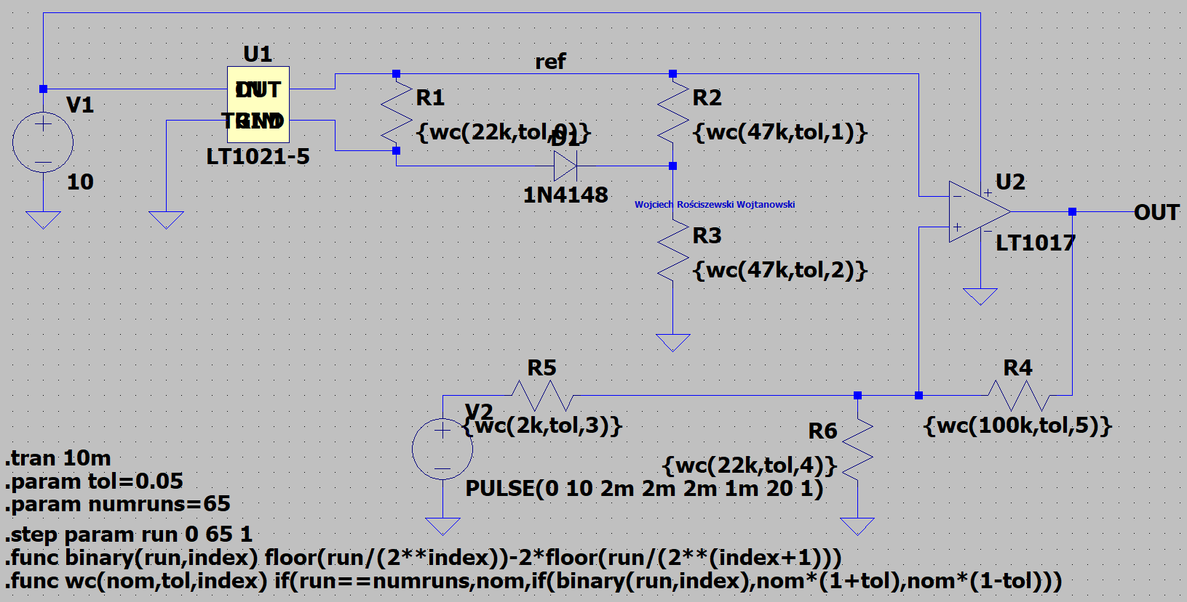

Figure 28 Diagram of The Tested Comparator System for WC Analysis.

In the below please see the output of our circuit

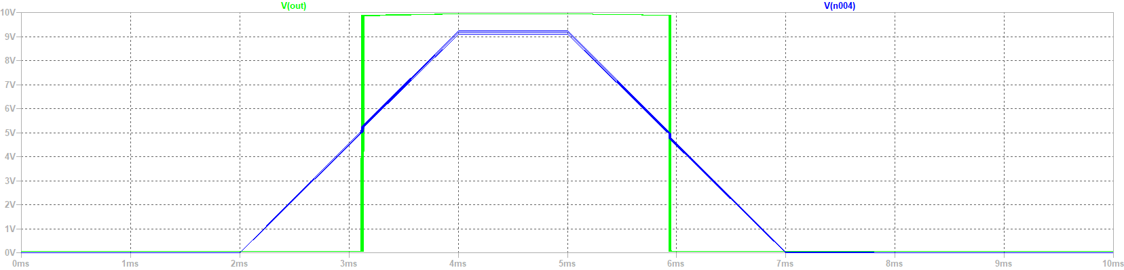

Figure 29 Plot Characteristic.

We see that the output of the system has also been affected since the upper threshold voltage varies from 5.5V to 5.6V whilst the lower threshold voltage varies from 5.3V to 5.2V.

# Part 3: Analysis of Band-Pass filter

For the next part of the exercise we create a band-pass filter for nominals values. Below please find the filter design circuit scheme.

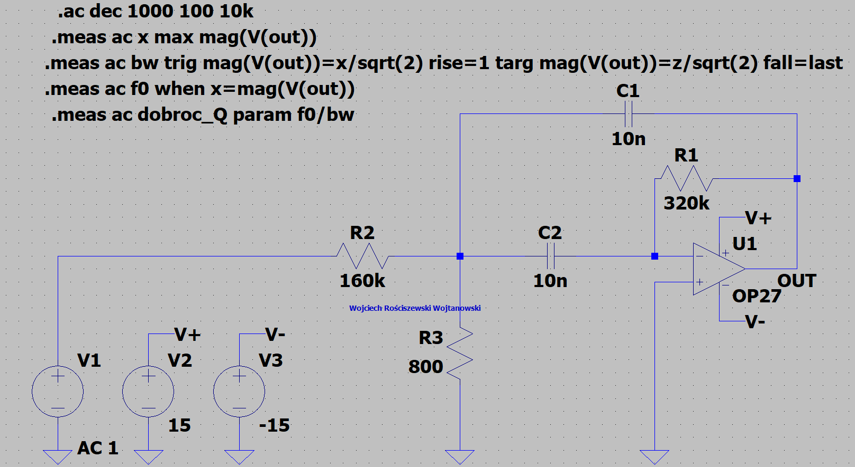

Figure 30 Diagram of the tested filter system.

In the below please see the output of our circuit

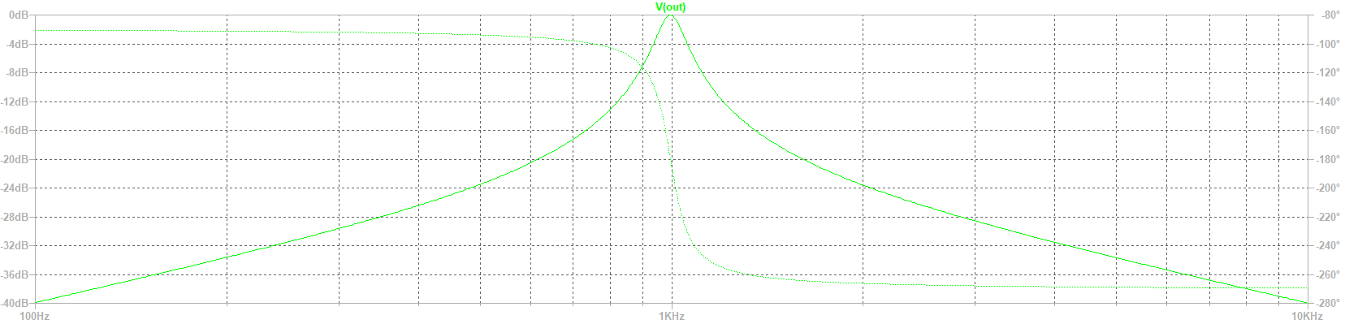

Figure 31 Plot Characteristic.

Below please find the quality filter Q characteristic according to the equation.

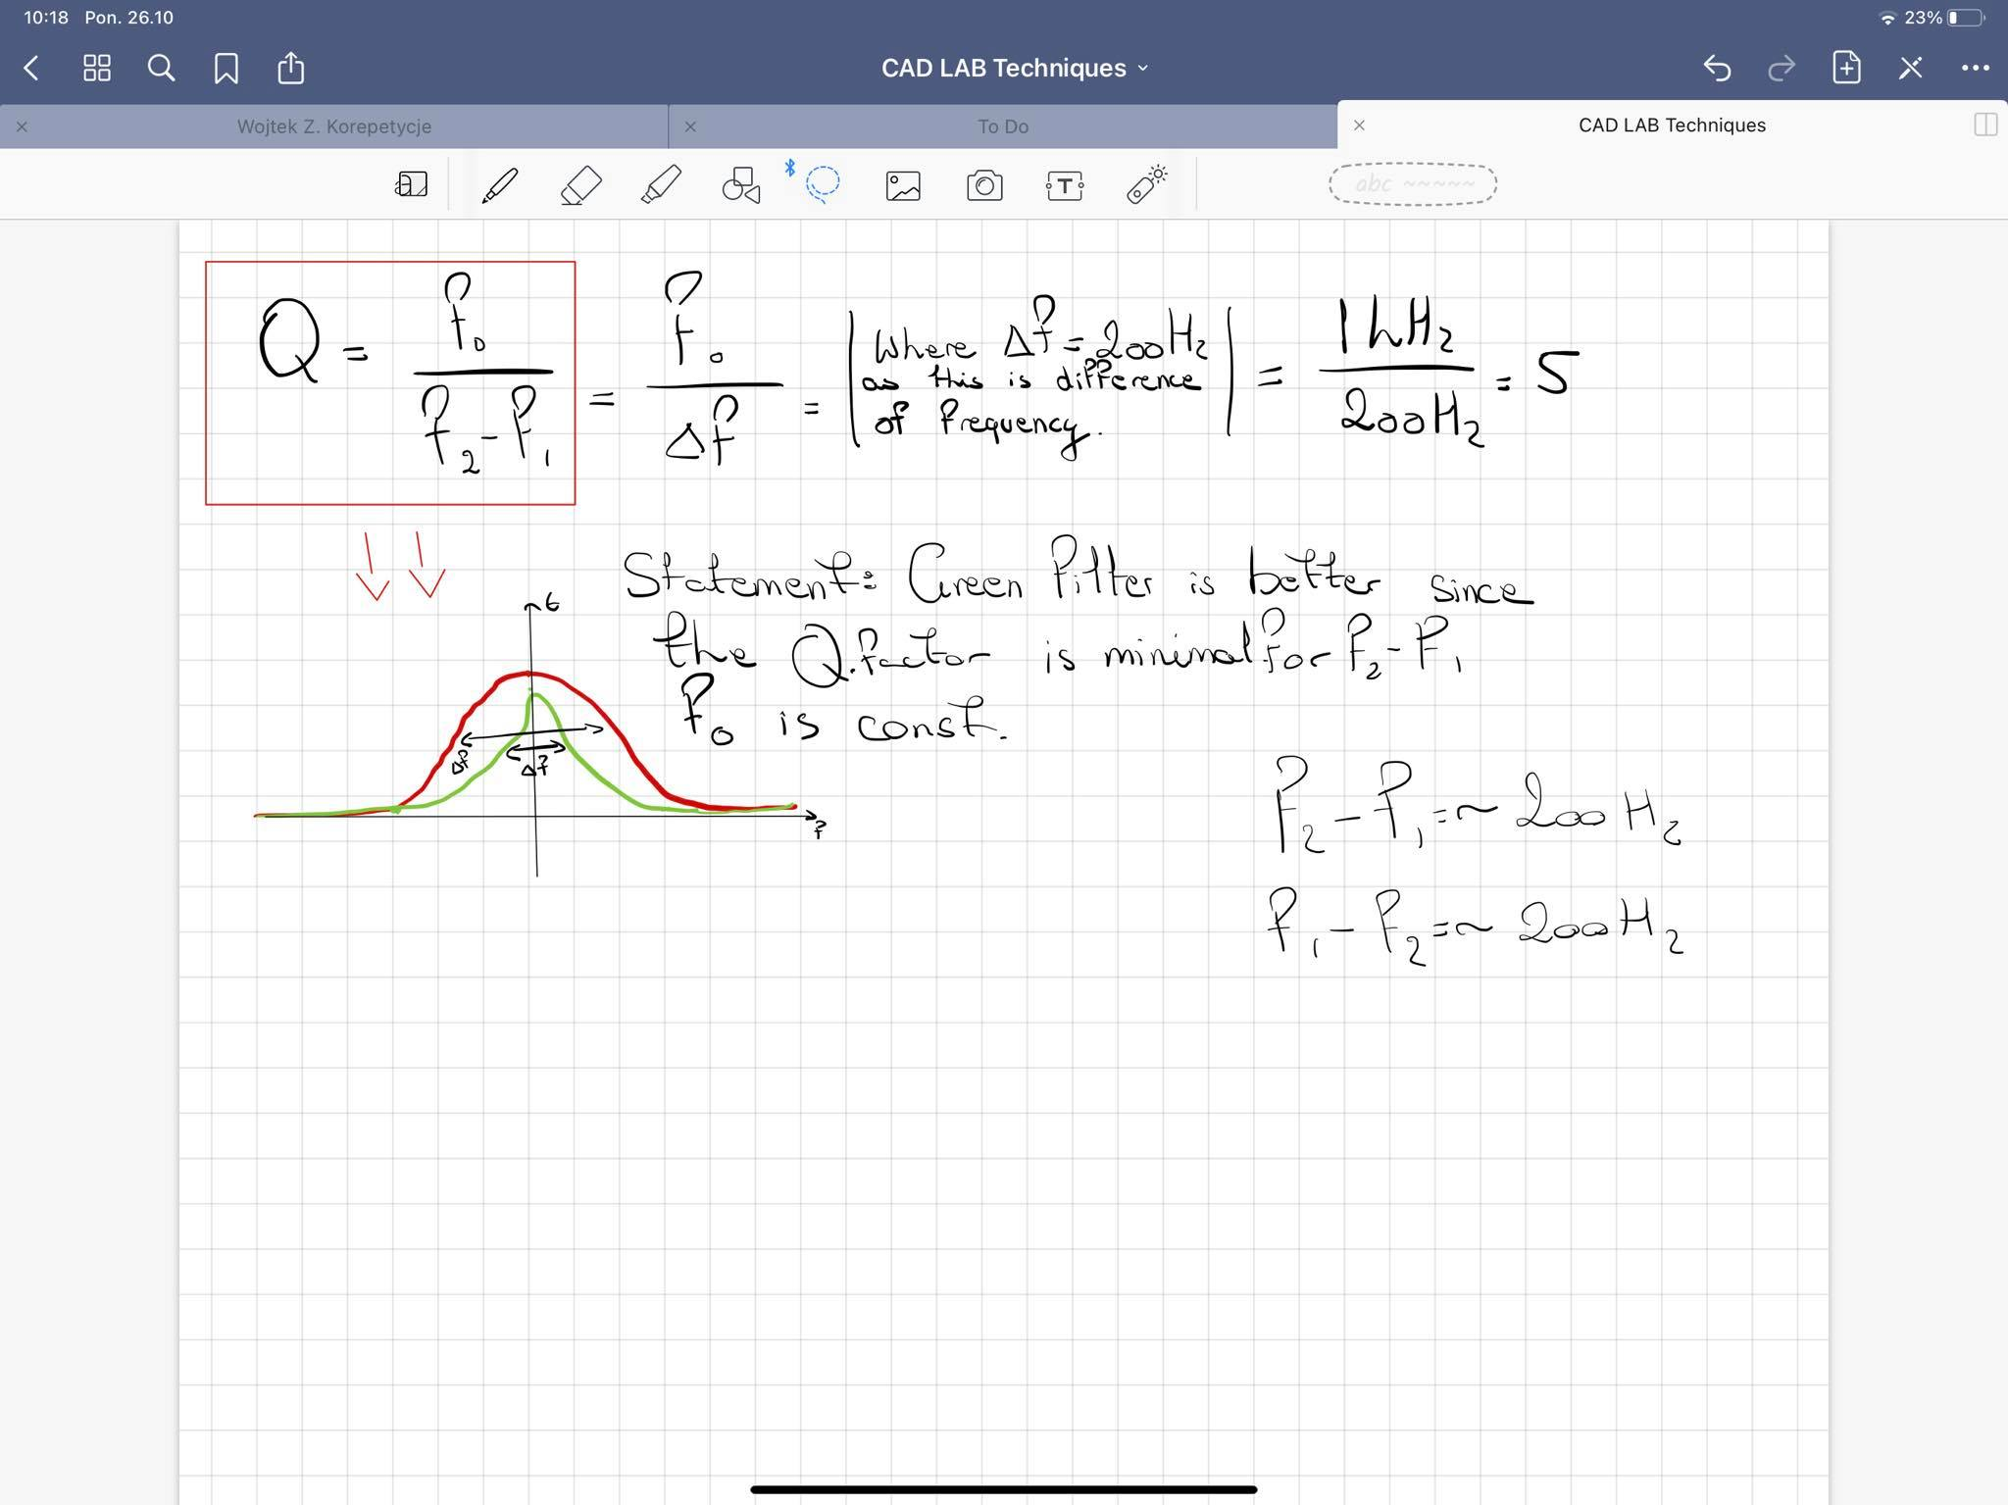

Figure 32 Quality Factor From Previous Exercise

So to calculate the quality, we know the following values.

f0=995Hz ; fg=1kHz ; fd=946Hz

So: Q=9.65

For the next step of the exercise we must perform the MC analysis, taking into account the 10% tolerance capacitors and 5% tolerance for resistors.

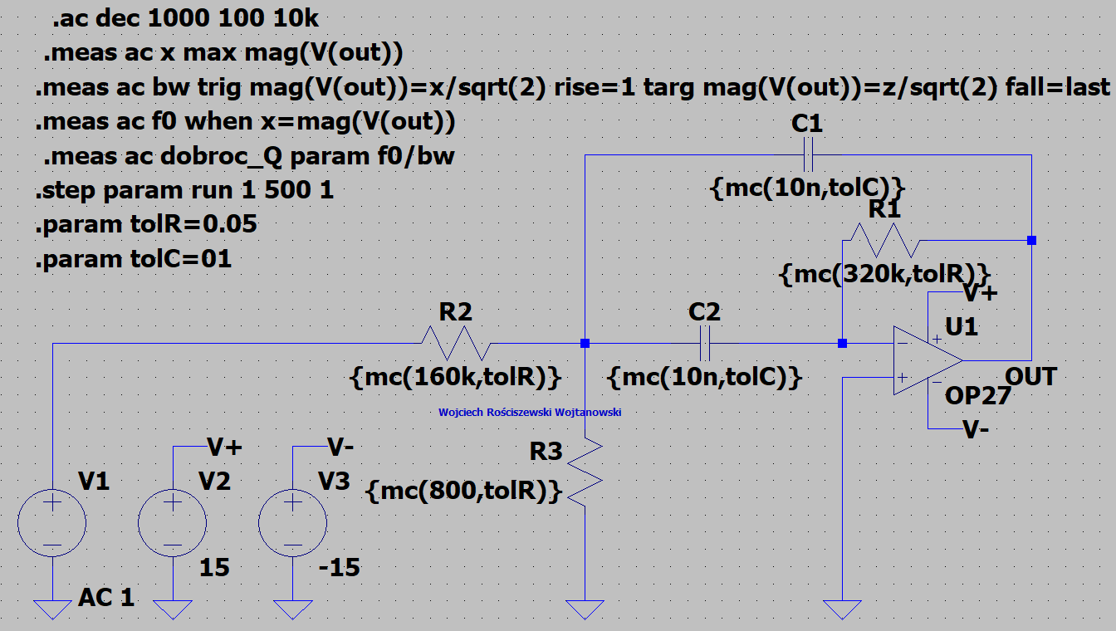

Figure 33 Diagram of the tested filter system for MC analysis.

In the below please see the output of our circuit

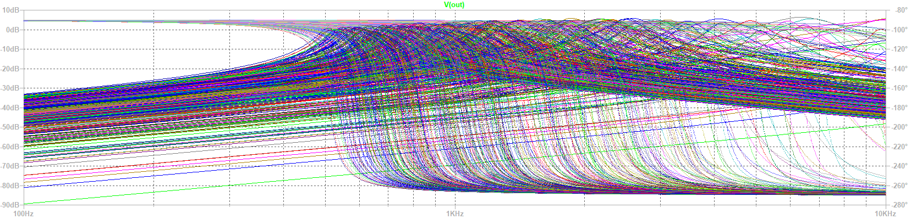

Figure 34 Plot Characteristic.

Max f0=1127 Hz

Min f0=881 Hz

Central Frequency:

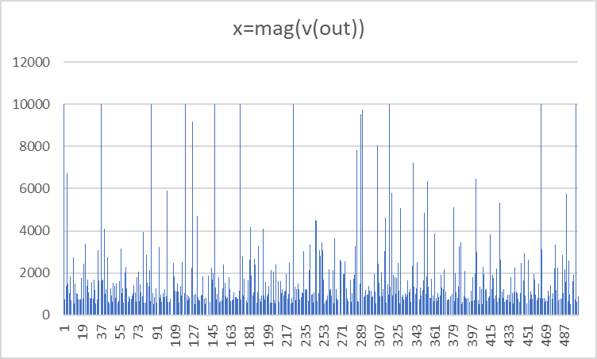

Figure 35 x=mag(vout)

For the next step of the exercise we must perform the WC analysis, taking into account the 10% tolerance capacitors and 5% tolerance for resistors.

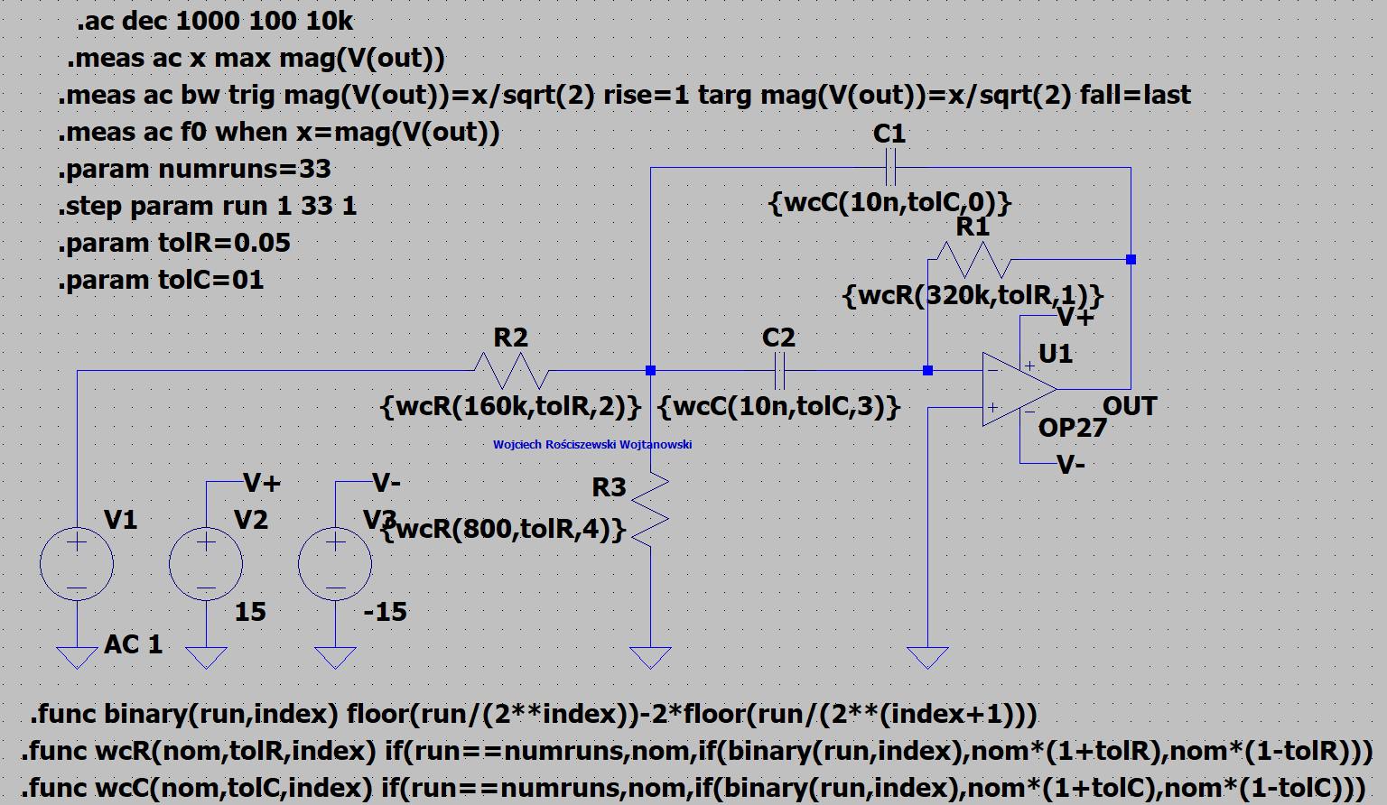

Figure 36 Scheme of the tested filter system for WC analysis.

In the below please see the output of our circuit

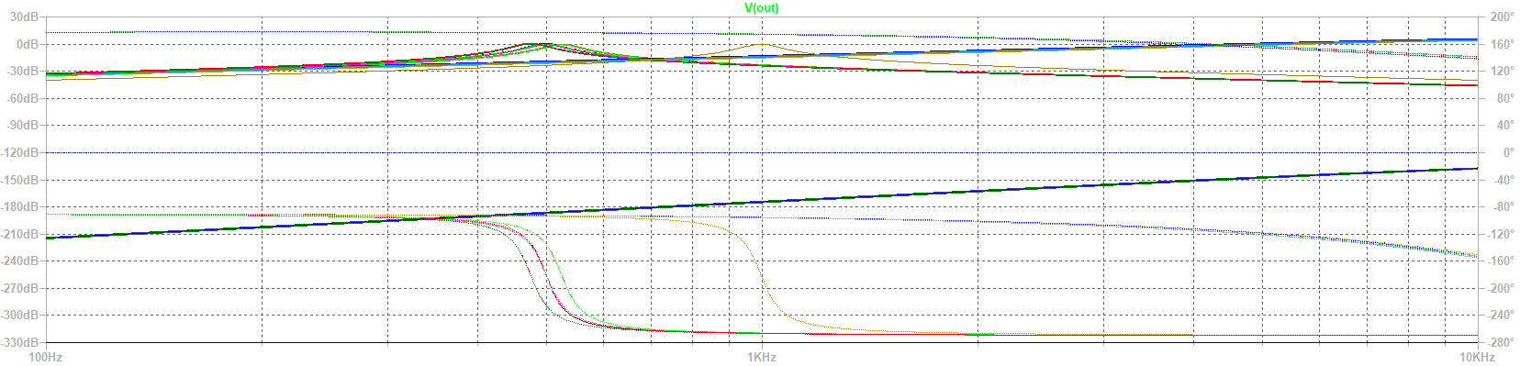

Figure 37 Plot Characteristic.

Central Frequency:

Max f0=114 Hz

Min f0=862 Hz

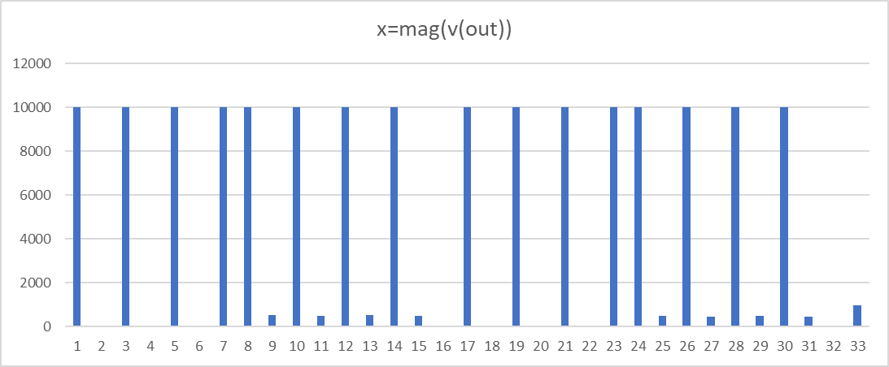

Figure 38 x=mag(vout)

# Part 4: Homework

For the first part of the homework task we will develop a band pass filter as previously, identically. This time we will alter the values of the temperature for resistors and capacitors – we will lower it and see the effects it makes on the system performance.

Below please see the circuit that has been used for this part.

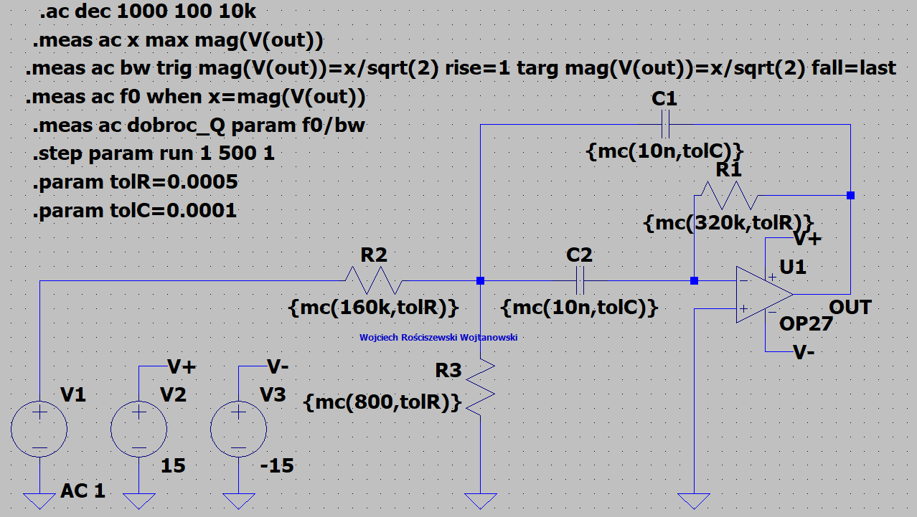

Figure 39 Band Pass Filter Circuit.

In the below please see the output of our circuit.

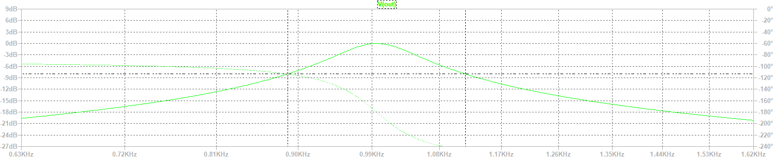

Figure 40 Plot Characteristic.

Below please find the quality filter Q characteristic according to the equation.

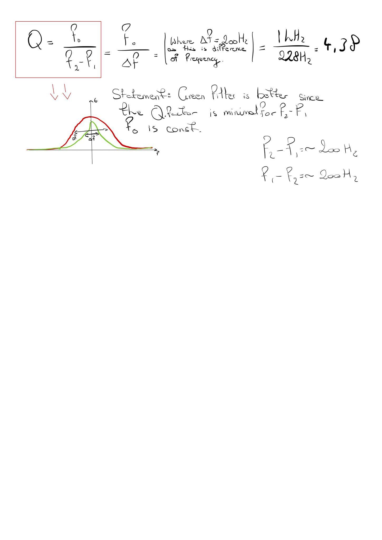

Figure 41 Quality Factor.

What did we observe? We observed that by changing the tolerance of our capacitors and resistors we have influence our systems behavior to change and the quality factor of your band pass filter has been lowered by roughly 0.62.

For the second part of the homework task we will develop a transistor type amplifier circuit system, and then we will perform similar tests as to the ones performed during exercises. Please note that for these systems I will be using a 10% value for resistor tolerance.

In the below please find the provided circuit from our course instruction manual.

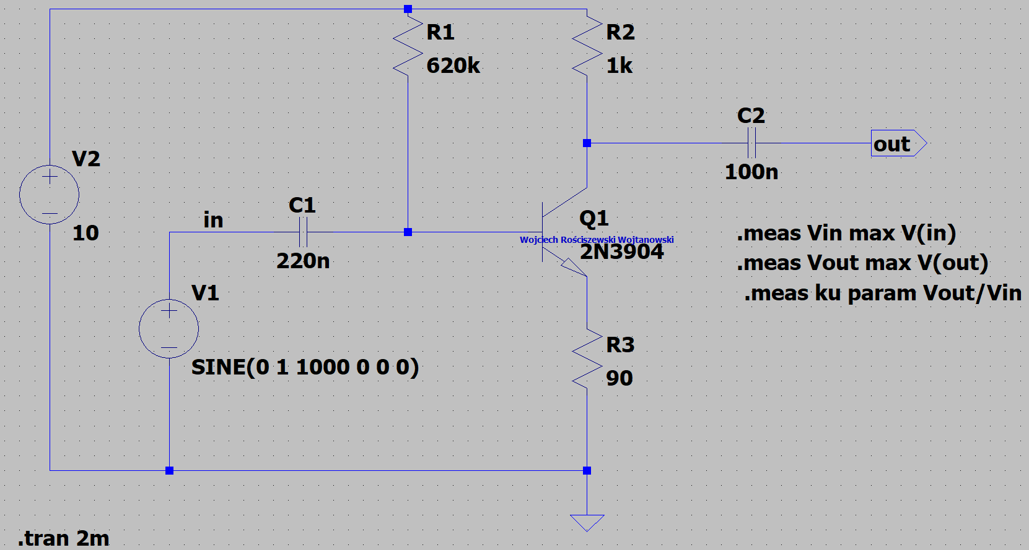

Figure 42 Diagram of a transistor amplifier

Please see in the figure below the output of this system. We see that the sinusoidal waveform is amplified.

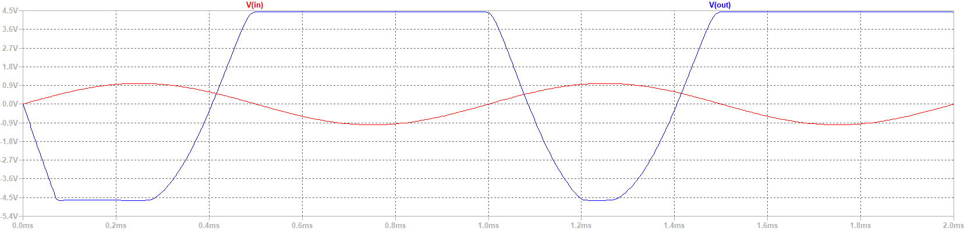

Figure 43 Plot Charactersistic

Please see the input waveform in red, and output in blue. We clearly see our amplification.

Below please see measurement results:

**vin: MAX(v(in))=0.999989 FROM 0 TO 0.002**

**vout: MAX(v(out))=4.45289 FROM 0 TO 0.002**

**ku: vout/vin=4.45294**

We see that this system amplifies input characteristic to 4.45 V.

Now we will perform the MC Analysis:

In the below please find our new system: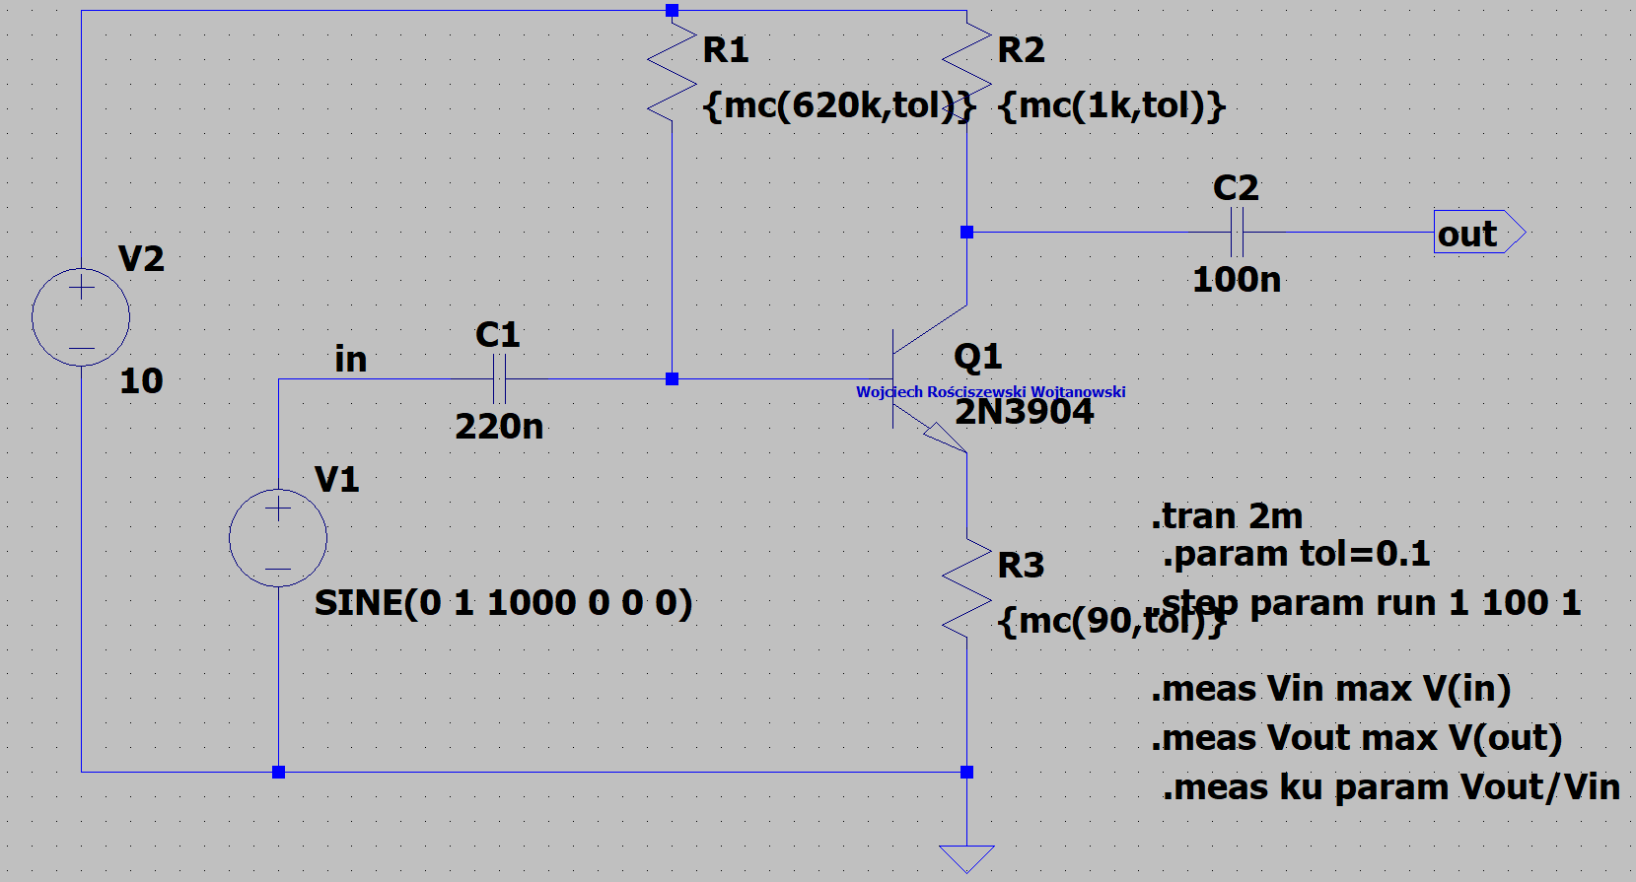

Figure 44 MC Analysis.

Please see in the figure below the output of this system. We see that the sinusoidal waveform is amplified.

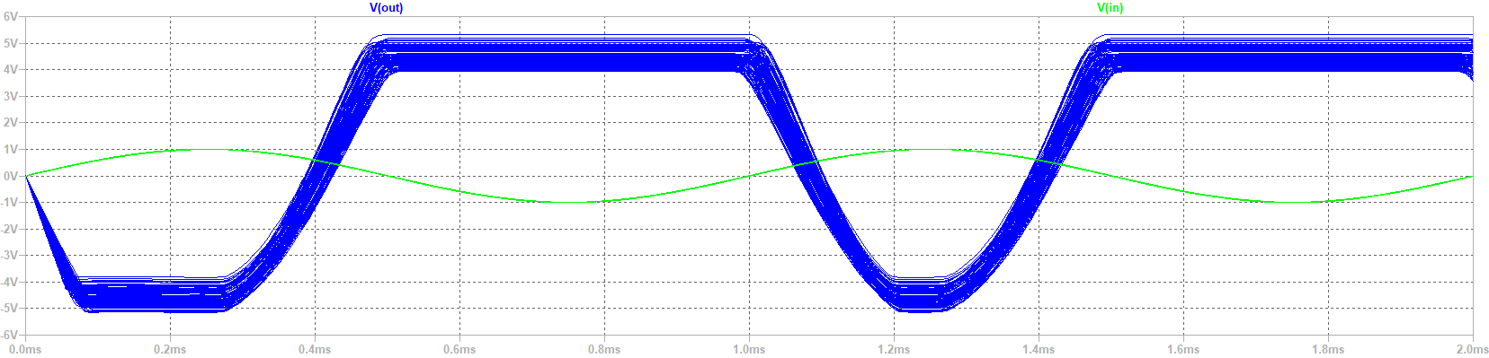

Figure 45 Plot Characteristic.

We see in the figure above how the tolerance of the resistive components in our system changes the entire operation of our system, maybe not greatly but as mentioned previously in the report sensitive systems such as radio receivers might show impact of this.

Now we will perform the WC Analysis:

In the below please find our new system:

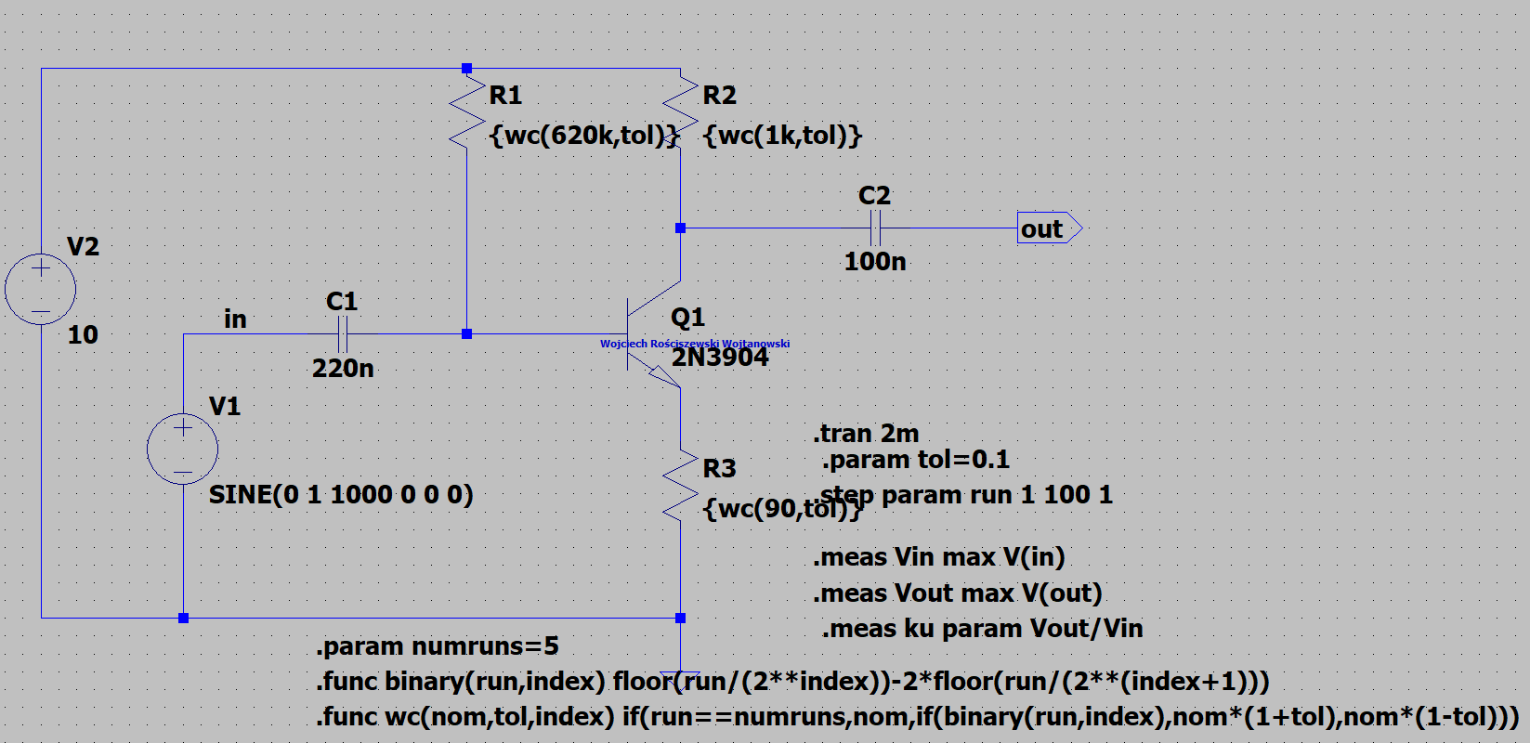

Figure 46 WC Analysis.

Please see in the figure below the output of this system. We see that the sinusoidal waveform is amplified.

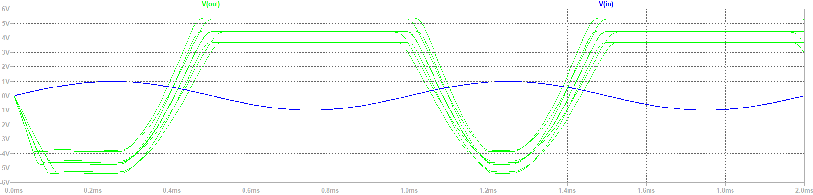

Figure 47 Plot Characteristic.

From the figure below we see that the signal of course is amplified but we see a strange event being carried out, as the amplitude of the signal is changed according to tolerance. Therefore, through this activity we see how greatly a system can be affected by the tolerance of the resistive elements. Out of curiosity I will do the WC analysis including the temperature coefficients. I will use the values used in the previous homework activity. I believe we will see a bigger impact of how temperature and tolerance of a resistor can affect the system behavior. I now understand why technicians before calibrating their equipment first let the device run and pre-heat for an hour or two so that all of the voltages stabilize.

In the below please find our new system:

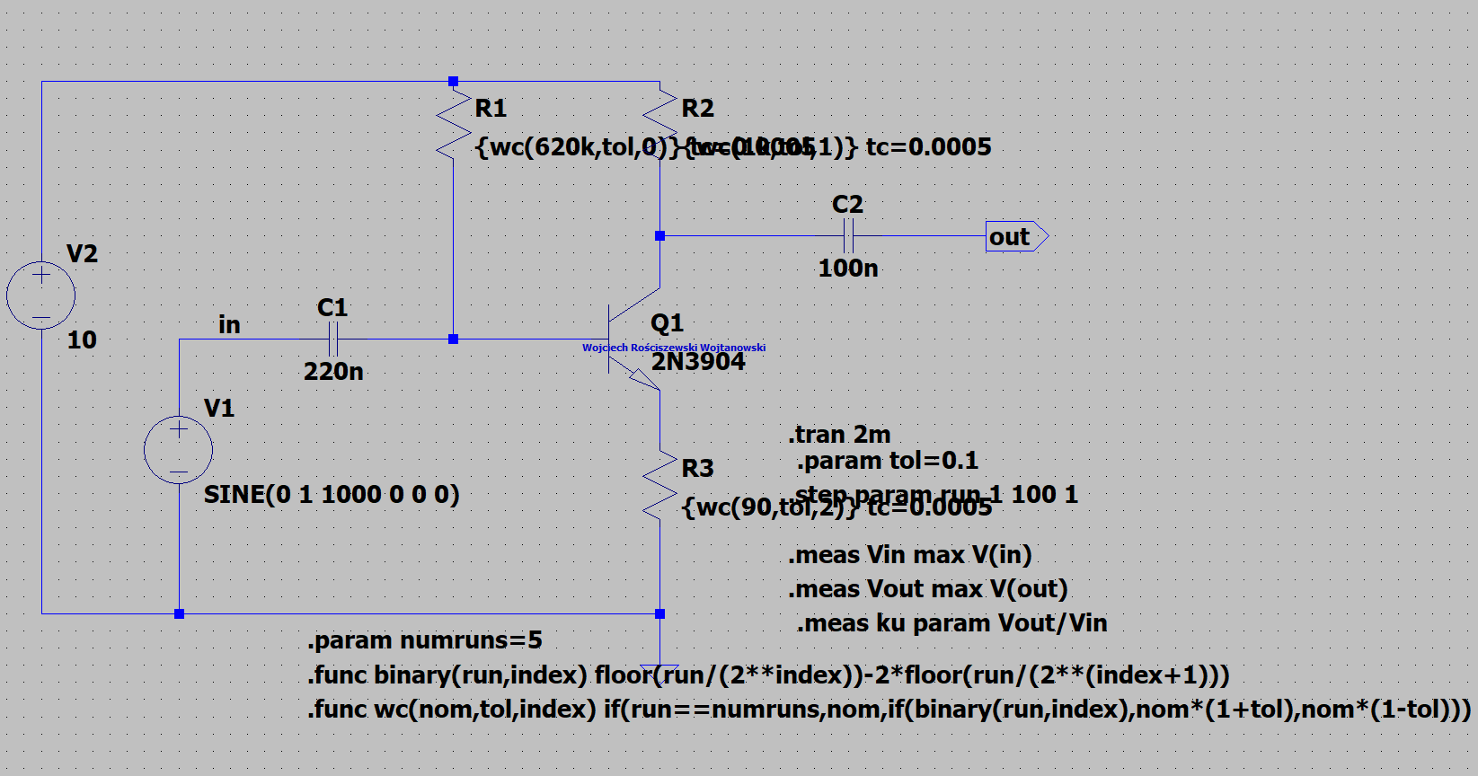

Figure 48 WC with TEMP.

Please see in the figure below the output of this system. We see that the sinusoidal waveform is amplified.



Figure Plot Characteristic.

What we see is basically the same output, or similar. After inspection there are very small changes to the signal, therefore I will conclude with the fact that the used temperature coefficient did not effect the system greatly.